Name: Mary-Rose Tracy
Date: 09/26/2024
Professor: Ukesh Chawal
Subject: IE 3301-011
HW 6:
- pg 185: 6.3, 6.5, 6.7, 6.11​
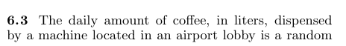
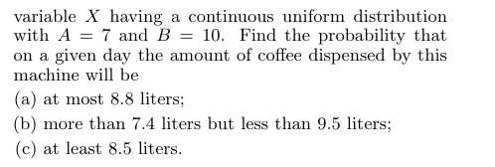
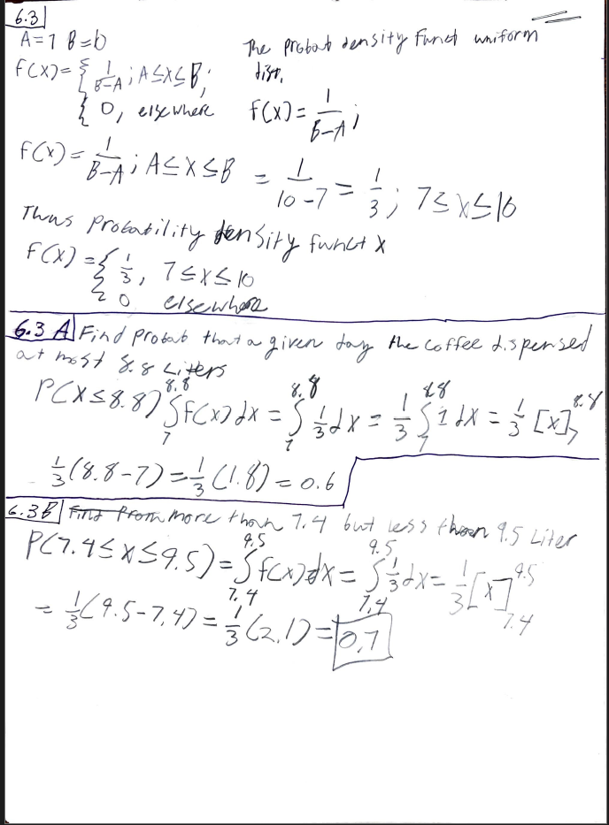
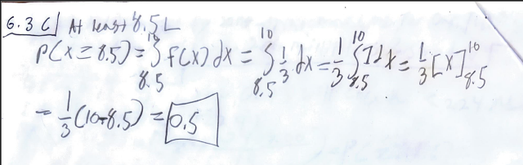
vvvv ON EXCEL vvvv
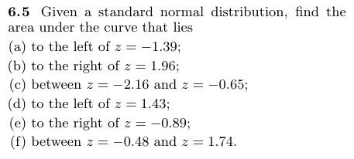
Did code to find the area, excel kept on messing up the graphs, so I decided to draw them because they weren’t being drawn on excel
- =NORM.S.DIST(-1.39, TRUE)
0.08226
- =1 - NORM.S.DIST(1.96, TRUE)
0.025
- =NORM.S.DIST(-0.65, TRUE) - NORM.S.DIST(-2.16, TRUE)
0.2425
- =NORM.S.DIST(1.43, TRUE)
0.9236
- =1 - NORM.S.DIST(-0.89, TRUE)
0.8133
- =NORM.S.DIST(1.74, TRUE) - NORM.S.DIST(-0.48, TRUE)
0.6435
They all automatically calculated the area as shown in the sceenshots:
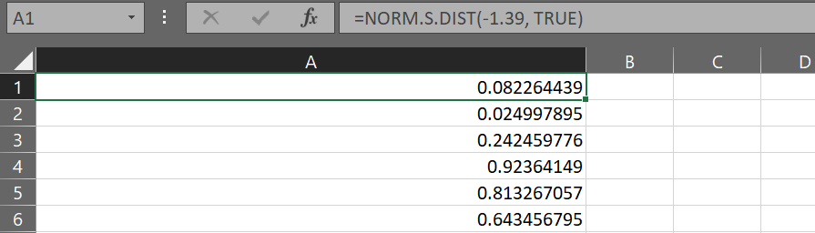

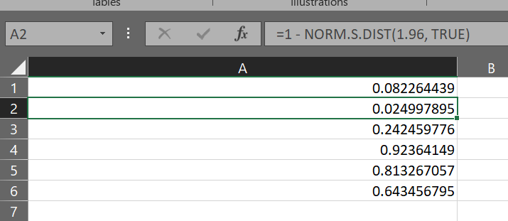
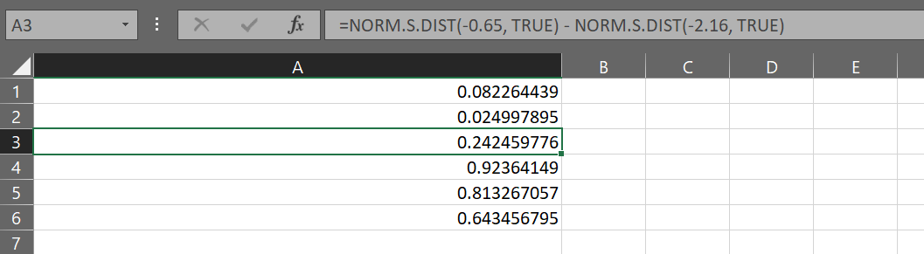
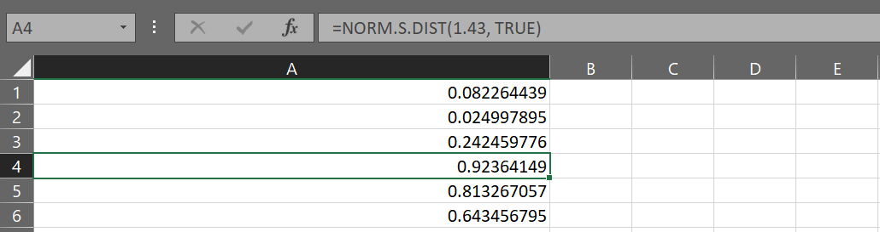
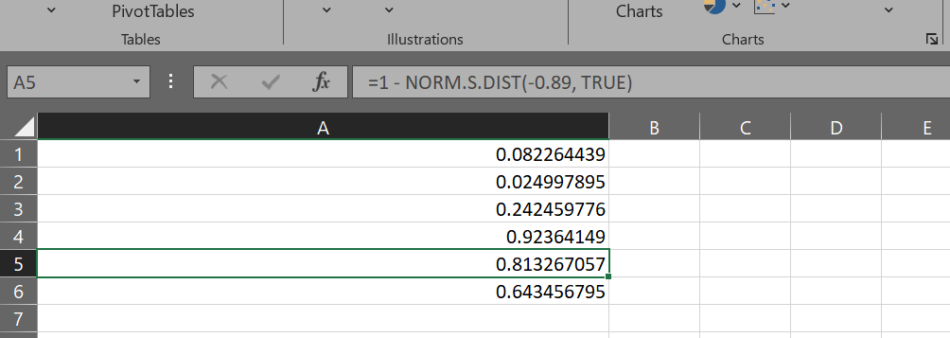
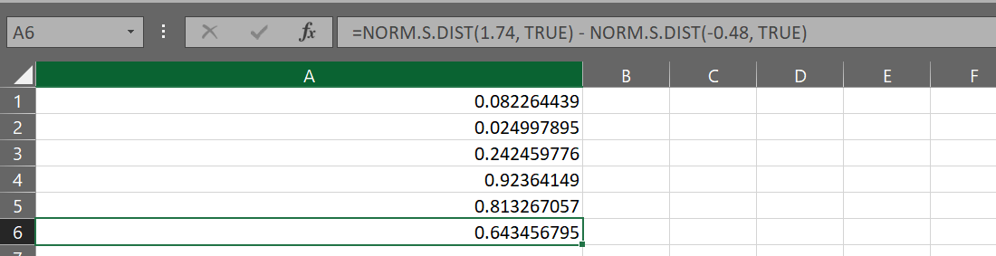
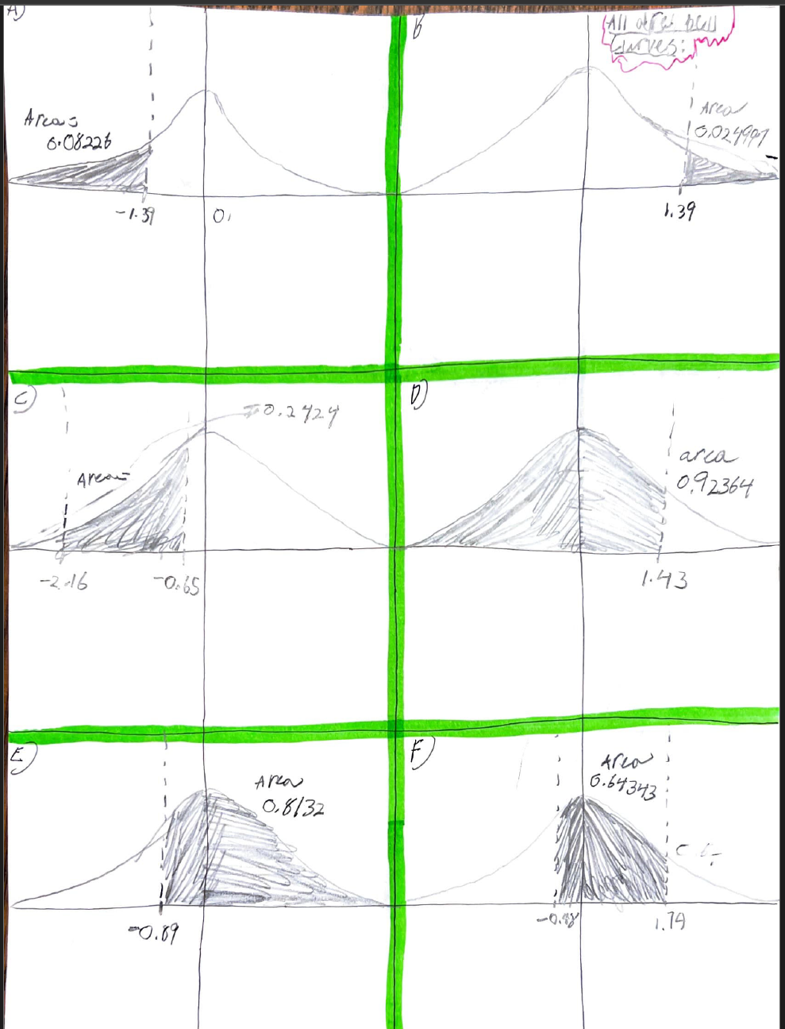
^^^^ ON EXCEL ^^^^
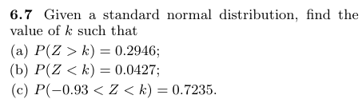
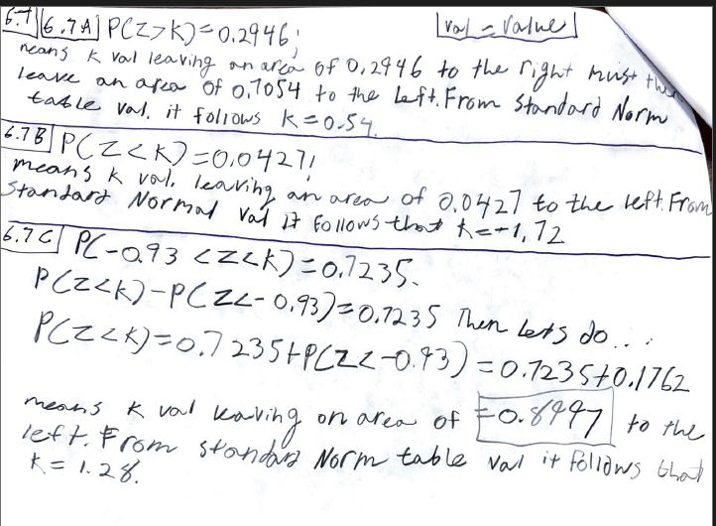

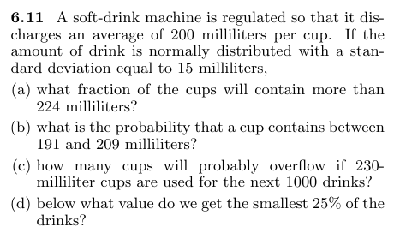
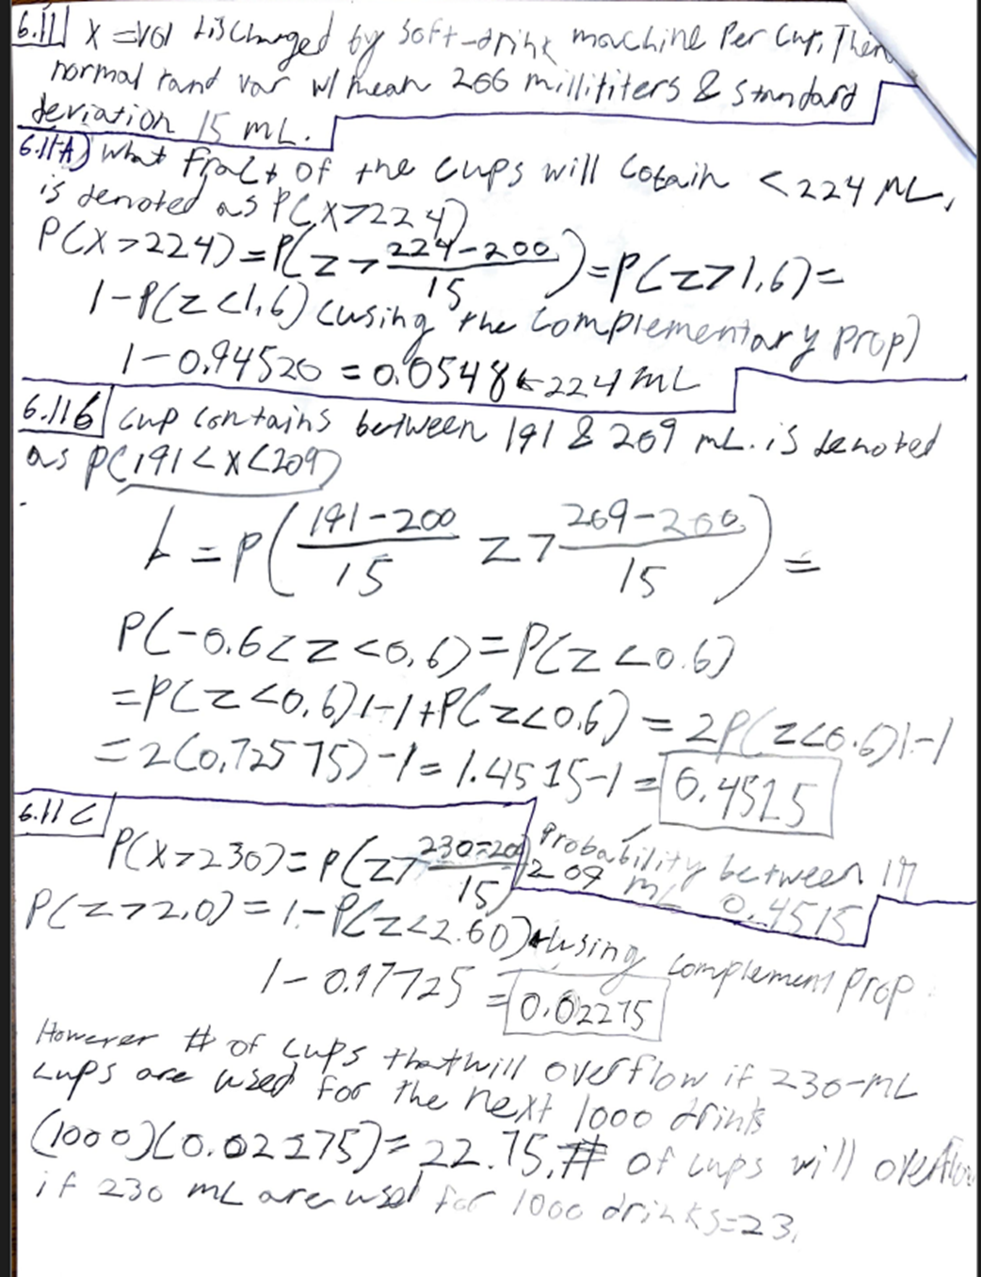
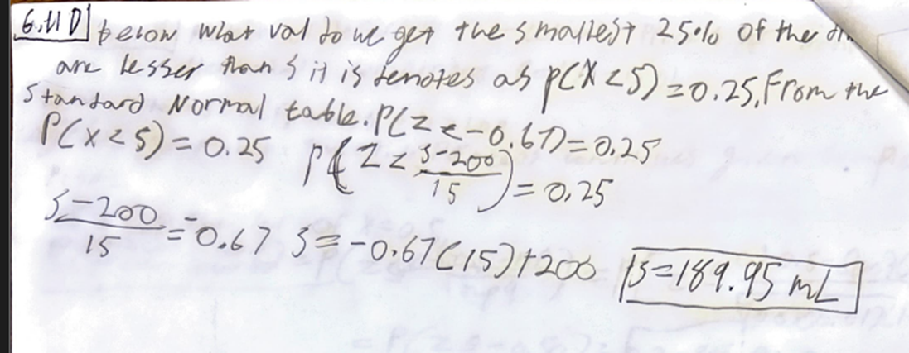
- pg 193: 6.25, 6.33​
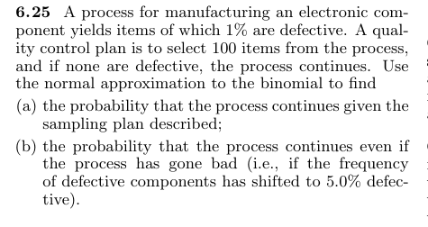
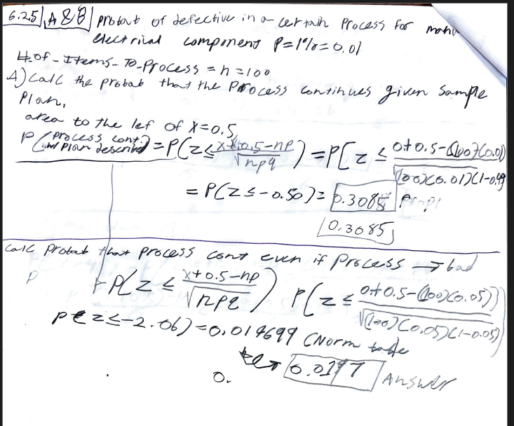
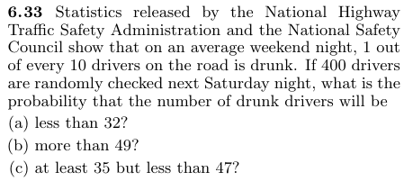
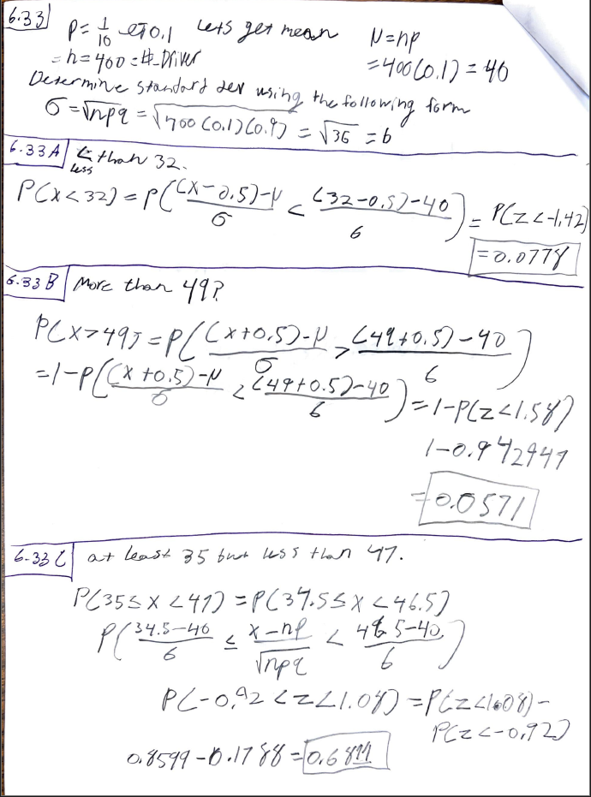
- pg 206: 6.45, 6.53, 6.56, 6.57, 6.58, 6.59
